1. Write a pig script to find no of complaints which got timely response

//Query

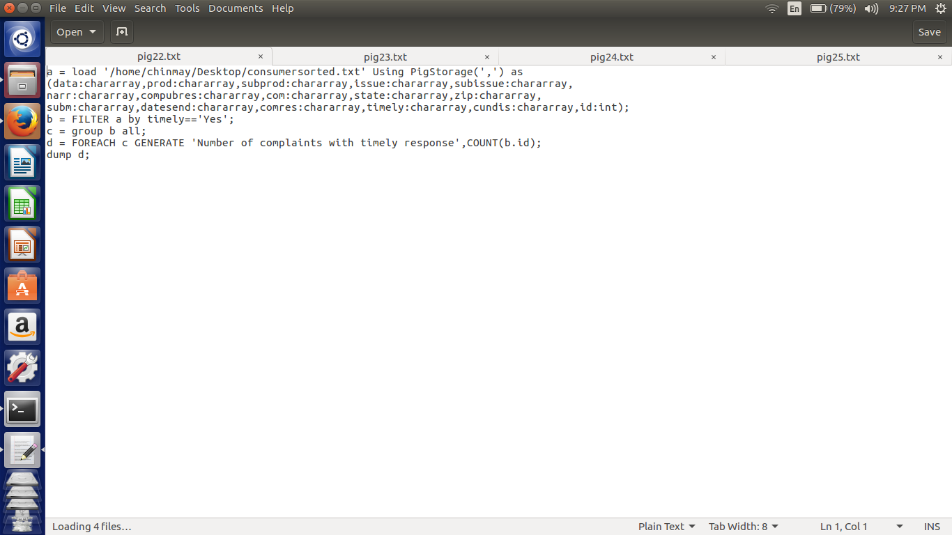

Here in this script first we are loading the file according to respective datatypes. Then Filtering the data using the if the complaint has got the timely response or not.

Next Group by all and get the count of ids to know how many complaints got the timely response.

//Implementation

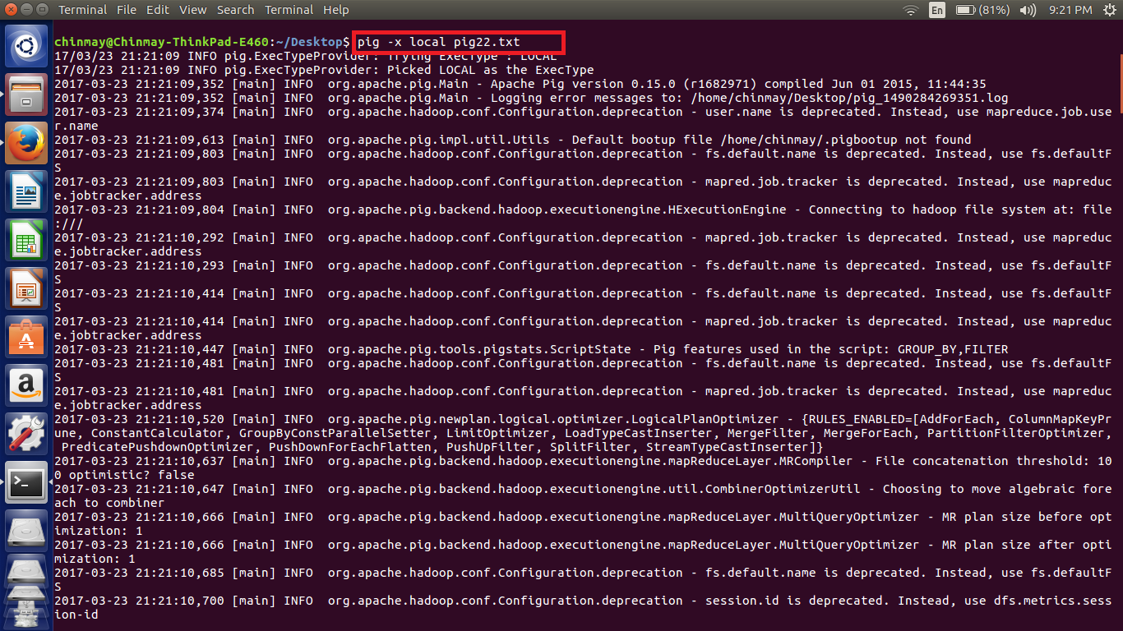

//Output

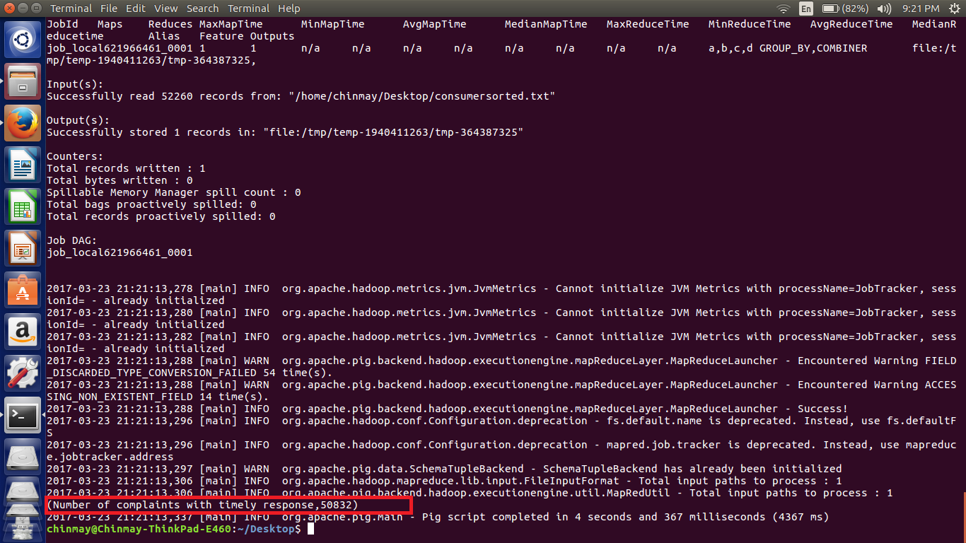

So there are 50832 complaints that got the timely response.

***NOTE - The file used for the implementation is also attached.***